EEM Release Notes

for

Version 3.17 released as of

20/07/2018 11:58 AM

Table of Contents

1. Introduction 3

2. Compatible Products 3

3. Installation Steps 3

4. New Features 3

5. Bug Fixes 4

6. Known Problems and Workarounds 4

# Introduction

This document communicates the major new features, bug fixes and setup changes in this release of the EEM. It also documents known problems and workarounds.

# Compatible Products

This release has been tested on the following platforms and products:

* Windows OS 2012 on the Server
* Windows OS 7.0 on the Client
* MS SQL Server 2012
* Internet Explorer 11

# Installation Steps

* Backup the EEM Production Binaries for future use
* Download the Release rar files from the git hub.
* Stop the EEM Production Website on IIS
* Extract any one rar file which will automatically extract all required EEM binaries and related files.
* After successful extraction, copy the files to the EEM release location on the EEM server.
* Go to the Scripts\Upgrade folder in the released location and run Setup.cmd
* Restart the EEM Production Website on IIS

# New Features

None

# Bug Fixes

**5.1 Bug Description**

Bring back the exchange type mailing

**Changes:**

* + Exchange mailing service feature is brought back. You can switch between Exchange and SMTP type mailing

For Exchange

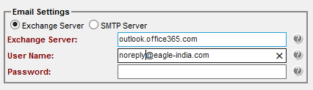

For SMTP

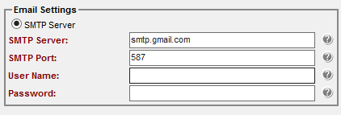

* + While running SQL Script command please provide EEM installed path (shared path if the binary is in different machine)

Sample:

Setup.cmd <ServerName> <UserName> <Password> <EEM Release Path>

<Auto Import>

**Example**:



# Known Problems and Workarounds

None